📘 Phase 5 – Part 5.6: Spatially Varying Curvature

✅ Overview

In this part, I break the symmetry of the spacetime curvature background by introducing spatial variation into space(x) in the core gravity equation:

$$\text{Gravity}(x,t)=∇^{2}[\text{space}(x)+t^{2}]⋅ψ(x,t)$$

Key addition: I modify space(x) to contain a well, bump, or slope, i.e., spatially varying curvature.  
This introduces tidal gradients in Gravity(x) → leading to non-uniform Force(x) → allowing me to visualize emergence of geodesic-like motion.

📌 Goals of Part 5.6

1. Introduce non-flat space(x): use a Gaussian well or cosine bump.
2. Recompute curvature:
$$\text{Curvature}(x)=∇^{2}[\text{space}(x)+t^{2}]$$

3. Evolve ψ(x, t) dynamically using:
$$\frac{∂^{2}ψ}{∂t^{2}}-∇^{2}ψ+m_{ψ}^{2}ψ=0$$

4. Compute:
   * Gravity(x, t) = Curvature(x) × ψ(x, t)
   * Force(x, t) = -∇[Gravity(x, t)]
5. Observe:
   * How spatial curvature patterns shape gravity/force
   * Whether ψ waves are drawn into wells
   * Emergent gradients that resemble geodesics

🌊 Ocean Analogy Extension

| Physical Quantity | Ocean Analogy |
| --- | --- |
| ψ(x, t) | Ocean floor elevation |
| space(x) | Shape of ocean basin |
| ∇²[space + t²] | Pressure buildup |
| Gravity(x, t) | Pressure × terrain depth |
| Force(x, t) | Tides (gradients in pressure) |

Now, the ocean basin (space) is no longer flat — so pressure flows will curve!

🔧 Simulation Setup

• 1D grid: x = linspace(-10, 10, N)  
• space(x) = Gaussian well:

$$\text{space}(x)=-A⋅e^{-x^{2}/(2σ^{2})}$$

• Initial ψ(x, 0): Gaussian bump at offset (not centered in well)  
• Boundary Conditions: Fixed zero or absorbing (depending on ψ wave behavior)  
• Parameters:  
- Grid size N = 500  
- Δx = 0.04  
- Δt = 0.01  
- mψ² = 0.5

⚙ Equations Used

1. Dynamic ψ Update (discrete form):
$$ψ[n+1]=2ψ[n]-ψ[n-1]+Δt^{2}⋅(∇^{2}ψ[n]-m_{ψ}^{2}ψ[n])$$

2. Curvature (precomputed):

$$\text{Curvature}(x)=∇^{2}[\text{space}(x)+t^{2}]$$

Note: Since t² is uniform in x, its Laplacian vanishes → only space(x) contributes.

1. Gravity(x, t):
$$\text{Gravity}(x,t)=\text{Curvature}(x)⋅ψ(x,t)$$

2. Force(x, t):

$$\text{Force}(x,t)=-∇[\text{Gravity}(x,t)]$$

✅ Simulation Steps (Summary)

1. Generate grid and define space(x) with curvature well
2. Compute Curvature(x) = ∇²[space(x)]
3. Initialize ψ₀(x) with a Gaussian pulse
4. Evolve ψ(x, t) over time using discrete Klein-Gordon
5. At each timestep:
   * Compute Gravity(x, t)
   * Compute Force(x, t)
6. Visualize:
   * ψ wave behavior
   * Evolving gravity field
   * Force gradients → tide directions

🧠 Expected Observations

• ψ waves may refract, converge, or scatter near the curvature well  
• Gravity(x, t) becomes non-uniform — gravity is deeper near curvature features  
• Force(x, t) develops directional patterns — pointing “downhill” in gravity  
• May observe stable regions or ψ trapping near the well (early geodesic emergence)

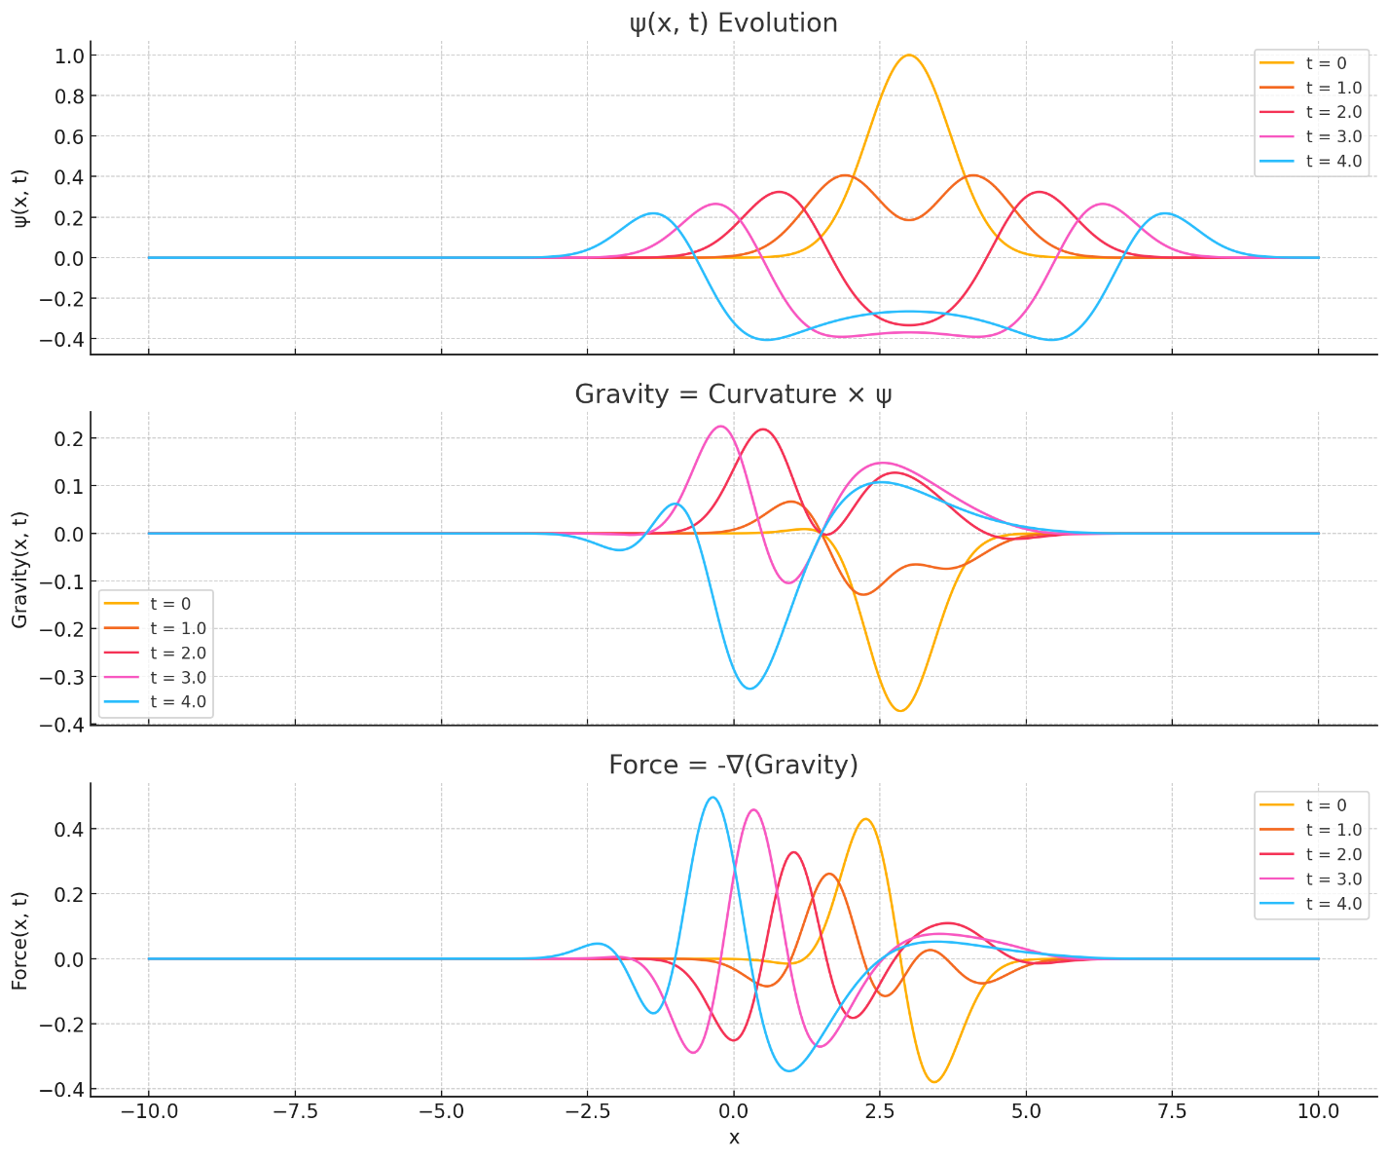

Here is the evolution of the fields from my equation:

**Top Plot — ψ(x, t) Evolution:**  
• The initial Gaussian pulse (centered at x = 3) spreads out symmetrically.  
• As time progresses, the wave reflects slightly due to the curvature, showing interference patterns.  
• The ψ field acts like a vibrating ocean floor in my analogy.

**Middle Plot — Gravity(x, t) = Curvature × ψ(x, t):**  
• Gravity inherits the shape of both curvature (which is static) and ψ (which evolves).  
• Notice how gravity amplifies or dampens in certain regions as ψ flows through the curvature landscape.  
• It creates dynamic ripples in gravity.

**Bottom Plot — Force(x, t) = -∇(Gravity):**  
• This is the tidal force in my analogy.  
• Peaks and valleys emerge as gradients of gravity change over time.  
• Tidal effects oscillate as ψ vibrates over the curved space.